**Duty of Candour**

All health and social care services in Scotland have an organisational duty of candour. This is a legal requirement which means that when certain types of incidents happen, the people affected understand what has happened, receive an apology, and the organisation(s) learns how to improve for the future.

An important part of this duty is that we provide an annual report about the organisational duty of candour in our services. This report describes how our organisation, Balfron Health Centre, has operated the organisational duty of candour during the time between 01 April 2024 and 31 March 2025. If you have any questions or would like more information about Balfron Health Centre, please feel free to contact us on 01360 440515 or by email: [fv.balfronhealthcentre@nhs.scot](mailto:fv.balfronhealthcentre@nhs.scot)

|  |  |
| --- | --- |
| How many incidents happened to which the organisational duty of candour applies? | 0 |

Where something has happened that triggers the organisational duty of candour, our staff report this to Ali Worrall, Practice Manager at Balfron Health Centre. The Practice Manager records the incident and reports as necessary to NHS Forth Valley. We know that serious mistakes can be distressing for staff as well as people who receive care and treatment and their families. We therefore have occupational welfare support in place for our staff if they have been affected by an organisational duty of candour incident. Where a relevant person (i.e., children, patients, families, etc.) is affected by the incident that activated the organisational duty of candour, we provide them with links to wellbeing support services.

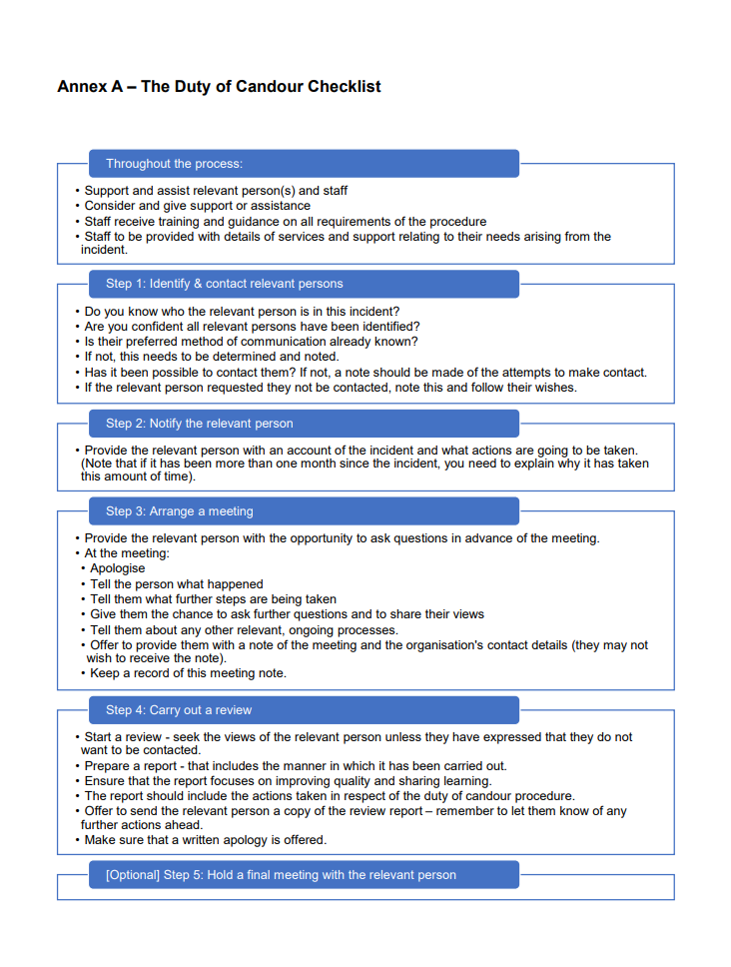

**Annex B – Summary of the Duty of Candour Procedure and Key Definitions**

The Health (Tobacco, Nicotine etc. and Care) (Scotland) Act 2016 received Royal Assent on 6 April 2016 and introduced a new organisational duty of candour on providers of health, care, and social work services. The procedure to be followed is set out in the Duty of Candour Procedure (Scotland) Regulations 2018, which came into force on 1 April 2018.

In this document:

* **“care service”** has the meaning given by section 47(1) of the Public Services Reform (Scotland) Act 2010, except that it does not include a service mentioned in paragraph (k) of that section (child minding)
* **“health service”** means services under the health service continued under section 1 of the 1978 Act, and an independent healthcare service mentioned in section 10F(1) of the 1978 Act
* **“social work services”** has the meaning given by section 48 of the Public Services Reform (Scotland) Act 2010

The organisational duty of candour procedure applies to incidents that the responsible person becomes aware of after 1 April 2018. For example, after 1 April 2018, if the responsible person becomes aware of unexpected psychological harm that occurred because of care provided to a relevant person before 1 April 2018, the organisational duty of candour procedure should be activated.

* **“incident**” means the unintended or unexpected incident by virtue of which section 21(2) of The Act applies to a person

The overall purpose of the organisational duty of candour is to ensure that organisations are open, honest and supportive when there is an unexpected or unintended incident resulting in death or harm, as defined in The Act.

In this document:

* **“The Act”** means the Health (Tobacco, Nicotine, etc. and Care) (Scotland) Act 2016
* **“The 1978 Act”** means the National Health Service (Scotland) Act 1978

**The Responsible Person**

The Act defines the “responsible person” as:

* a Health Board
* a person (other than an individual) who entered into a contract agreement or arrangement with a Health Board to provide a health service
* the Common Services Agency for the Scottish Health Service
* a person (other than an individual) providing an independent healthcare service
* a local authority
* a person (other than an individual) who provides a care service
* an individual who provides a care service and who employs, or has otherwise made arrangements with, other persons to assist with the provision of that service
* a person (other than an individual) who provides a social work service

The responsible person has responsibility for:

* carrying out the procedure
* undertaking any training required by regulations
* providing training, supervision and support to any person carrying out any part of the procedure as required by regulations
* reporting annually on the duty

**Incidents that activates the duty**

The organisational duty of candour procedure **must** be carried out by the responsible person as soon as reasonably practicable after becoming aware that an individual who has received a health, care, or social work service has been the subject of an unintended or unexpected incident, and in the reasonable opinion of a registered health professional has resulted in, or could result in:

* the death of the person
* a permanent lessening of bodily, sensory, motor, physiologic or intellectual functions (“severe harm”) harm, which is not severe, but which results in:
* an increase in the person’s treatment
  + changes to the structure of the person’s body
  + the shortening of the life expectancy of the person
  + an impairment of the sensory, motor or intellectual functions of the person which has lasted, or is likely to last, for a continuous period of at least 28 days
  + the person experiencing pain or psychological harm which has been, or is likely to be, experienced by the person for a continuous period of at least 28 days
  + the person requiring treatment by a registered health professional to prevent:
  + the death of the person
  + any injury to the person which, if left untreated, would lead to one or more of the outcomes mentioned above
  + **“registered health professional”** means a member of a profession to which section 60(2) of the Health Act 1999 applies

**The procedure**

* **“the procedure”** means the actions set out in Regulations 2 to 7 of the Duty of Candour Procedure (Scotland) Regulations 2018